**EXPERIMENT 25:** Create a Simple Web Application using Java or Python and host it in any Public Cloud Service Provider (Azure/GCP/AWS) to demonstrate Platform as a Service (PaaS).

**AIM:**

create a simple web site using any public cloud service provider (azure/gcp/aws) and check the public accessibility of the stored file to demonstrate storage as a service

**PROCEDURE:**

**STEP1:** firstly, go to appservice to create an webapp.

**step2:** enter the resource group and webapp name and region and select the linux os.

**step3:** after enter the all the necessary things click the review and create and click the create the web app.

**IMPLEMENTATION:**

**1. firstly, go to appservice to create an webapp**

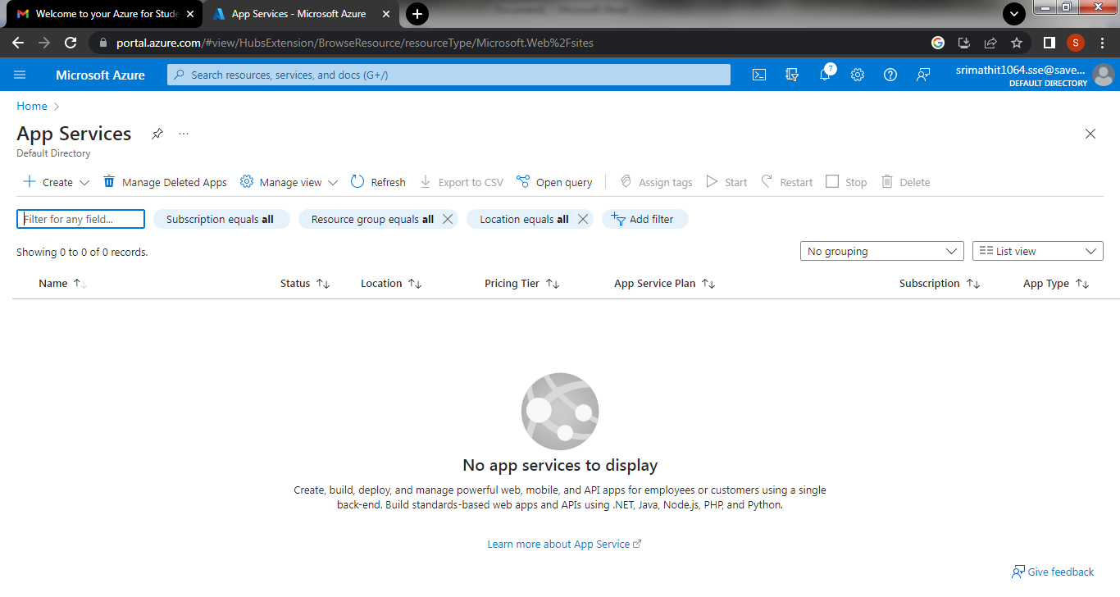

**2.Then click on create and select web App**

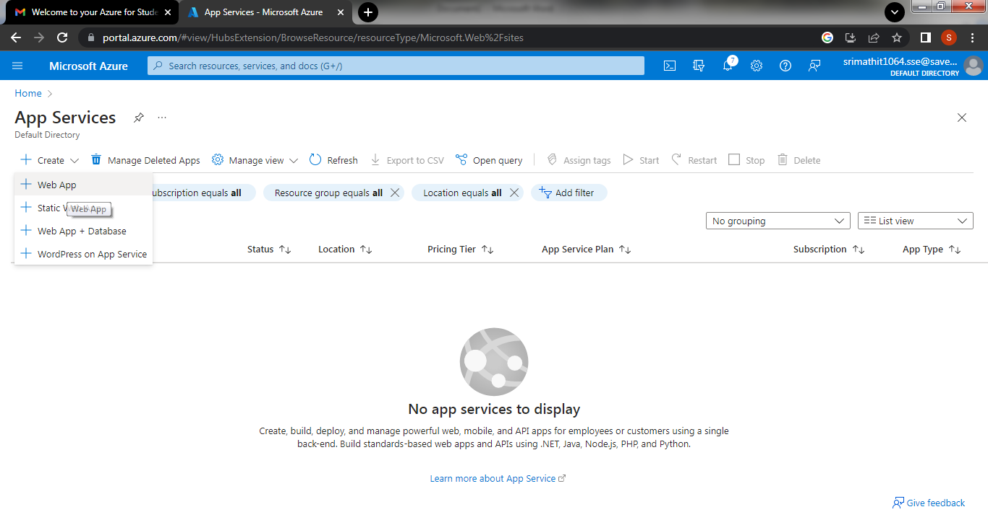

**3.By entering all the necessary things and click the review and create**

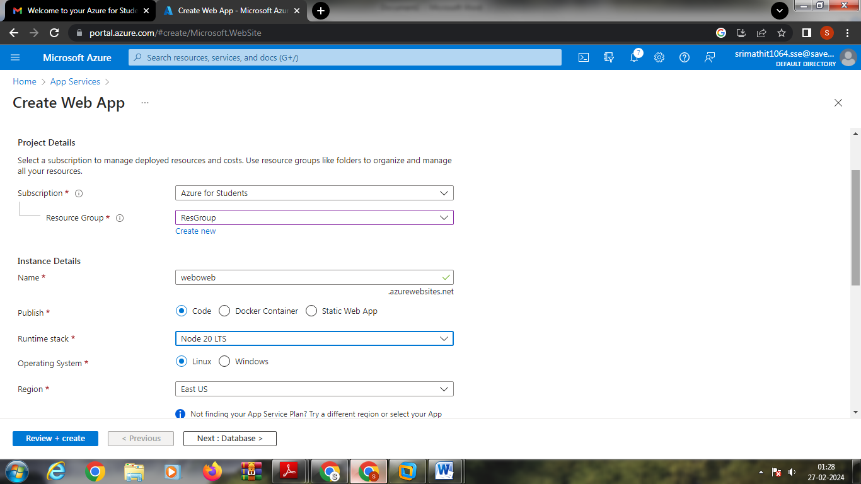

**4.And click the create button to create the web app**

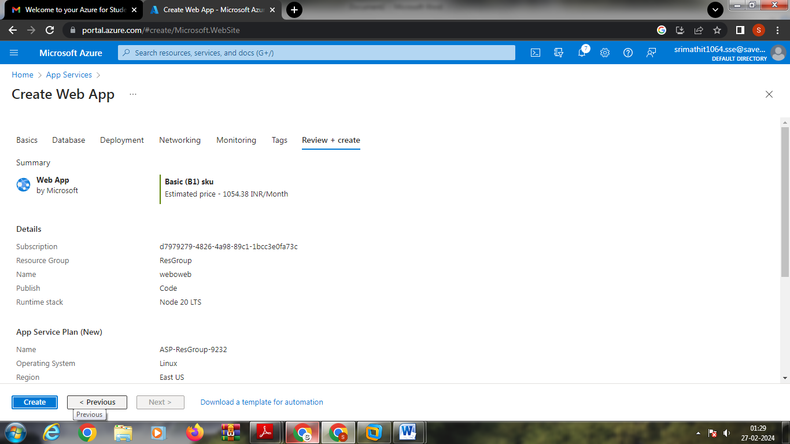

**5.And our deployment is completed**

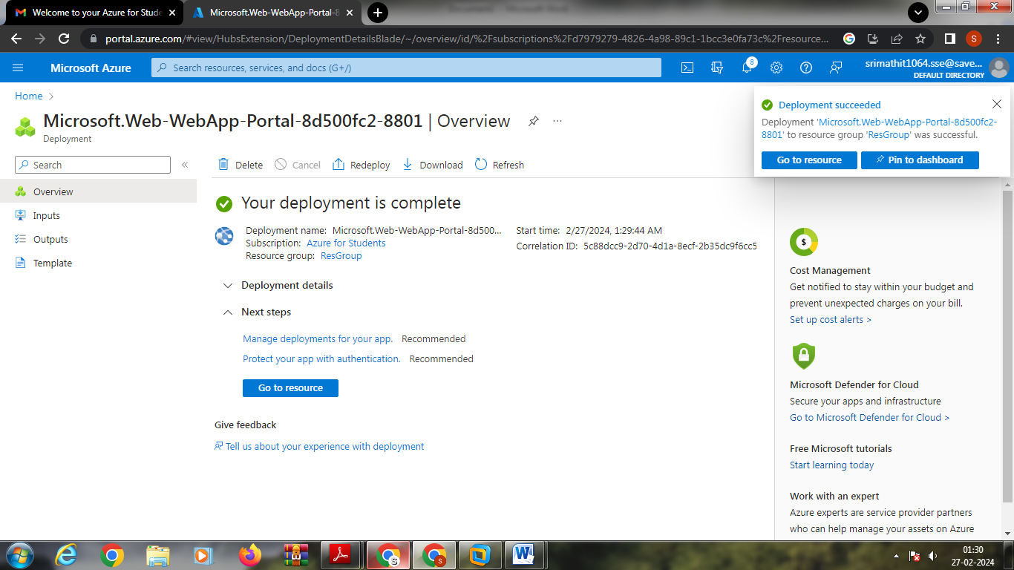

**6.Go to website URL link**

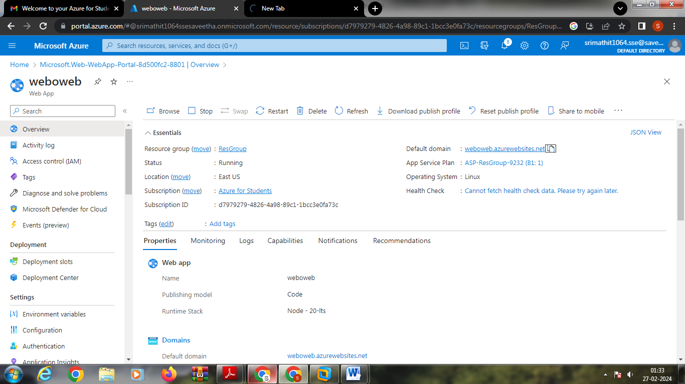

**7.This is our web service**

